Made a payment but need to update the withdraw frequency, amount, or billing information? Follow the below steps!
CBMC uses iDonate to process donations and membership payments. iDonate is a donation focused, ministry partner, but participation in a PAG/YP team is defined as a non-exempt, taxable membership.
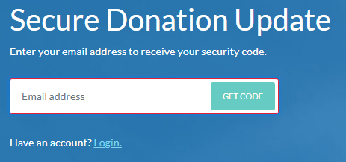
Visit https://donor.idonate.com/login
Enter your primary email, the same email you used when you made your gift. *This will be the email address you received your previous receipt at.

Click “GET CODE”.
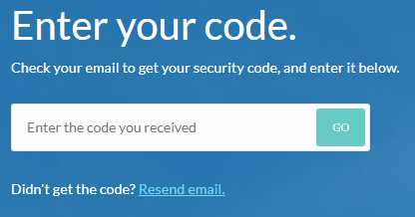
Check that email’s inbox for an email from iDonate.
Enter the 6-digit verification code from the email.
Click “GO”.
*Depending on your email settings, this might be in spam.
*Click “Resend email” if you haven’t received the email after 30 minutes.

You can create an iDonate account to simplify future visits. To do this, click “Login”, enter your email address used for your previous iDonate payment, and click “Forgot password?” to have a password reset link sent to you. Next time you visit https://donor.idonate.com/login you’ll be able to click “Login” and just enter your email and password.
Once you’ve verified your identity by entering the verification code or by logging in, you’ll see your dashboard with your Recurring Donations, Payment Methods, and Recent Transactions. 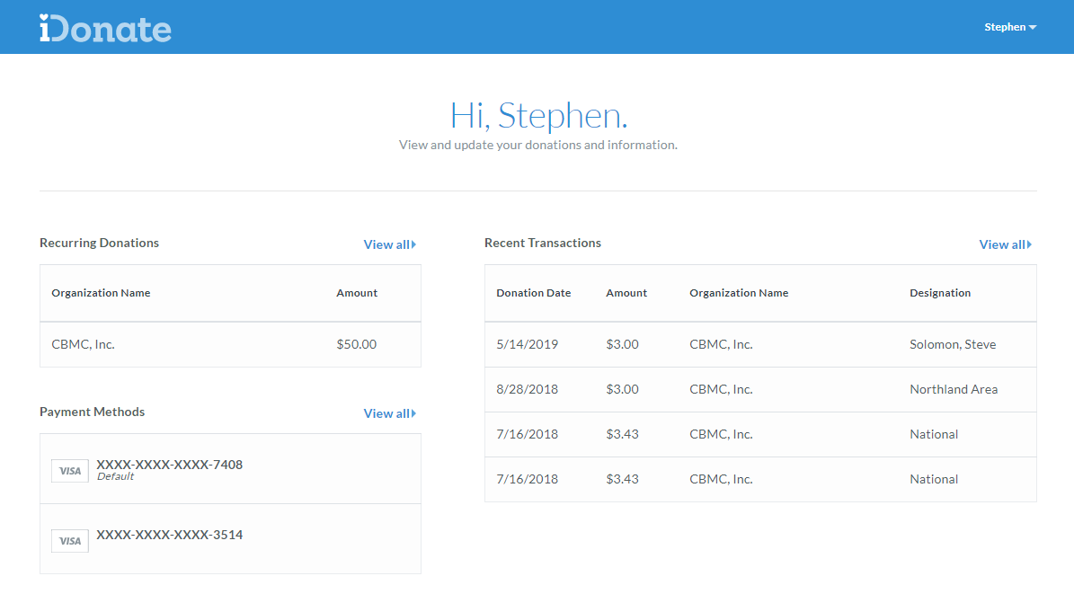
Click the “View all” link of any section to open it and make changes as needed. This includes adding a new payment method, updating an existing payment method, updating the frequency and amount of a recurring payment, and so on. Below, we will focus in on changing a recurring transaction.
Click your name from the top right to update your profile. This includes your full name, email, phone number, mailing address, and account password.
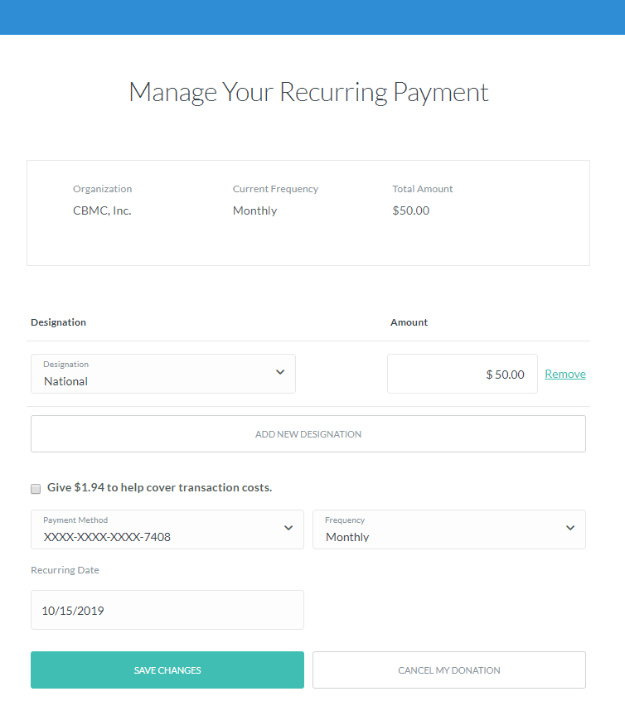
Click on your recurring donation to arrive at the screen to the left. From here, you can change Designations, add a new Designation, change the amount of your recurring donation, update your payment method, frequency and pull date. You can also cancel your donation.

